Databases Enhancement – Grazioso Salvare Rescue Dog Dashboard
Brandon Shank
Date: 06/15/2026

Artifact Description

I worked on the Grazioso Salvare Rescue Dog Dashboard application, which I originally created in CS-340. The purpose of this system is to allow users to search, filter, and visualize animal rescue data stored in a MongoDB database through an interactive dashboard interface.
This application combines Python, MongoDB, Jupyter Dash, Plotly, and Dash Leaflet to create a database-driven dashboard system. At its core, the project uses a custom-built Python module that follows the CRUD principles to talk to the MongoDB database. This allows it to fetch animal rescue information on the fly, rather than relying on static data or storing everything locally.
The system initially let users narrow down animals by the type of rescue they needed, like water, mountain, or disaster rescue. It had a dashboard with a table that could be interacted with, graphs that showed breed information in a visual way, and a map that showed where the selected animals were. All these features allowed users to directly work with and visualize rescue information from the database, right from the dashboard. This made it easy for them to get the information they needed, without having to leave the interface. The dashboard got its information straight from the MongoDB database, making it a powerful tool for understanding rescue operations.
While the original implementation successfully demonstrated database connectivity, CRUD operations, and dashboard interaction, several areas of the project could still be improved related to maintainability, filtering logic, validation, performance, scalability, and database organization.
Because of these limitations, the project was a strong candidate for enhancement.

Justification for Inclusion and Enhancements

I selected this project because it demonstrates practical database integration, CRUD operations, interactive filtering, and full-stack communication between a database system and a user interface. The project also demonstrates how database systems can be integrated into interactive applications that allow users to manipulate and visualize large amounts of information dynamically.
Another reason I selected this artifact is because the original implementation provided several opportunities for meaningful improvement beyond simply changing the visual appearance of the application.
For the updated version, I focused on improving the database structure, maintainability, scalability, filtering logic, validation, and overall organization of the application. Some of the main changes I made include:

• Reorganized database filtering logic into reusable database-layer functions inside the CRUD Python module.
• Added flexible filtering methods using the find_with_filters() function.
• Added rescue-specific reusable query handling using the rescue_filter() method.
• Improved database performance by implementing MongoDB indexing for commonly searched fields.
• Added aggregation support for breed and outcome analysis using MongoDB aggregation pipelines.
• Added stronger validation logic to improve data integrity and reduce invalid database operations.
• Added additional exception handling and error management to improve reliability and stability.
• Improved maintainability by separating dashboard interface logic from database query logic.
• Improved scalability by creating reusable and modular database-layer methods that can support future expansion.
• Added clearer organization and documentation throughout the project to improve readability and maintainability.
These enhancements helped transform the project from a basic database dashboard into a more structured, scalable, maintainable, and professionally organized database-driven application.

Course Outcomes

This enhancement helped demonstrate how databases, filtering systems, query optimization, and full-stack integration can be used to create scalable and maintainable software systems. The project demonstrates the ability to design and evaluate computing solutions that involve storing, manipulating, retrieving, and visualizing data from a MongoDB database.
One of the primary goals of this enhancement was improving maintainability and scalability, and I was able to accomplish that by restructuring the database logic into reusable methods inside the CRUD Python module. Separating database logic from dashboard interface logic improved modularity and created a cleaner software architecture.
The updated implementation also demonstrated the use of modern tools and technologies including MongoDB, Python, Jupyter Dash, Plotly, Dash Leaflet, and aggregation pipelines. With these technologies, the dashboard could update tables, graphs, and maps in real-time, based on the filtered data from the database. This made it possible to easily see how different factors affected the data, and to get a better understanding of what was going on. The use of these modern tools and technologies made the dashboard more interactive and user-friendly, and allowed for more in-depth analysis of the data.
Another important outcome demonstrated through this enhancement was improving database performance and reliability. Implementing indexing improved query efficiency and filtering speed, while validation and exception handling improved data integrity and application stability. These enhancements helped prepare the application to handle larger datasets more efficiently while improving overall system reliability.

One example of the performance improvements involved making changes to how the database searches for information. For instance, adding some shortcuts to the fields that people search for a lot, like the breed and type of animal, made it way faster to find what we're looking for. This is because the system didn't have to look through as much data when we were searching for specific things related to rescues. We also used something called aggregation pipelines, which made it easier to get a summary of the breeds and the outcomes. This way, we could get the information we needed right from the database, instead of having to do extra work on the dashboard.
The enhancement also demonstrated practical database optimization concepts including reusable filtering methods, aggregation support, indexing, query abstraction, and modular software design principles.
Overall, the project demonstrates the ability to apply database concepts, software engineering principles, query optimization techniques, and full-stack integration to create a more professional and scalable application.

Reflection

One thing that stood out to me during this enhancement was how important organization and modularity are when developing database-driven applications. In the original implementation, much of the database query logic was embedded directly inside the dashboard code itself. While the application functioned correctly, this approach made the system harder to maintain, expand, and reuse as additional functionality was added.
By shifting the filtering and query handling to reusable methods within the database layer of the CRUD Python module, I achieved a major boost in the project's maintainability and structure. This change allowed me to separate the dashboard interface from the database operations, resulting in a cleaner design that's more scalable and aligned with professional software engineering standards. This separation of concerns makes it easier to manage and update the project, as each component has a clear and distinct role. The database layer now handles all the data-related tasks, while the dashboard interface focuses on presenting the information to the user. This design not only improves the project's overall quality but also makes it more efficient to develop and maintain in the long run.

Another major improvement involved implementing indexing and aggregation support. Before this enhancement, the project relied mainly on basic MongoDB queries without additional optimization. But once we added indexes to the fields that people search for the most, it made a huge difference in how fast we could filter things. This really showed us how optimizing our database can help it handle bigger and bigger datasets. By making this change, we were able to make our project more efficient and scalable, which is important as our data continues to grow. This improvement also helped us understand the importance of database optimization techniques in improving performance.
I also learned how important validation and exception handling are when working with databases. At first, I was mainly focused on getting everything to work, but when I started testing it, I realized that if I didn't account for invalid queries or unexpected database problems, it could cause some real reliability issues. So, I went back and added some validation and exception handling, and it made a big difference - the whole application became a lot more stable and reliable.
I put the system to the test by trying out different invalid queries and unusual input values to see how it would handle them. This helped me figure out if the application could deal with errors in a smooth way and stop any invalid database operations from causing problems with the dashboard. After doing these tests, I felt more confident that the updated system was reliable and stable.
One challenge I faced during this enhancement was balancing dashboard functionality with backend organization. Because the dashboard relies heavily on dynamic updates between tables, graphs, and maps, restructuring the filtering logic required careful testing to ensure all dashboard components continued updating correctly after the database changes were implemented.
Another challenge involved configuring and troubleshooting MongoDB queries and ensuring that the dashboard callbacks updated correctly after introducing reusable filtering methods and aggregation support.
This improvement really helped me understand how to bring different parts of a database together, make queries run faster, and use MongoDB indexes and aggregation pipelines. I also learned about designing software in a modular way, making dashboards interactive, validating data, debugging, and creating applications that can handle a lot of users. Plus, it showed me why it's crucial to make sure database systems are easy to maintain, organized, and run well, especially when you're trying to make an existing system better.
These enhancements also relate directly to my long-term career goals in software development. Understanding how to build scalable database systems, optimize performance, and organize applications using modular design principles will be valuable when developing larger software systems in professional environments.

Evidence (Screenshots)

Figure 1: Dashboard Overview
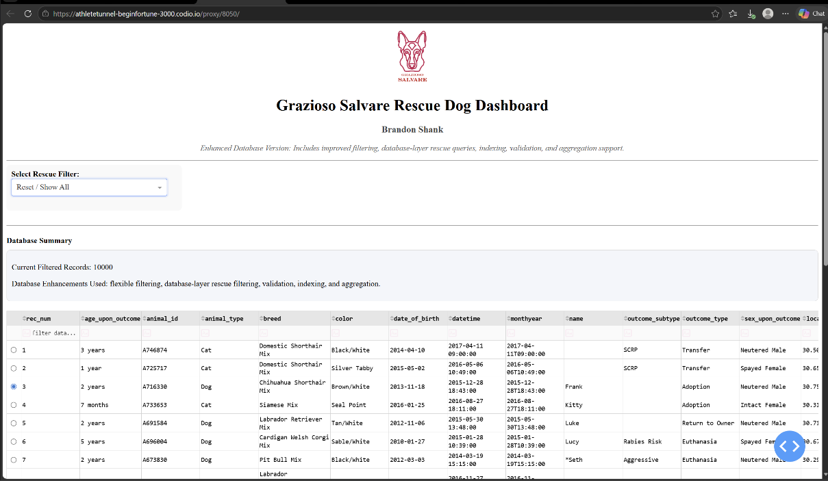
Enhanced Grazioso Salvare Rescue Dog Dashboard showing the updated interactive interface, filtering system, graph visualization, and integrated geographic mapping functionality.

Figure 2: Graph and Map Update
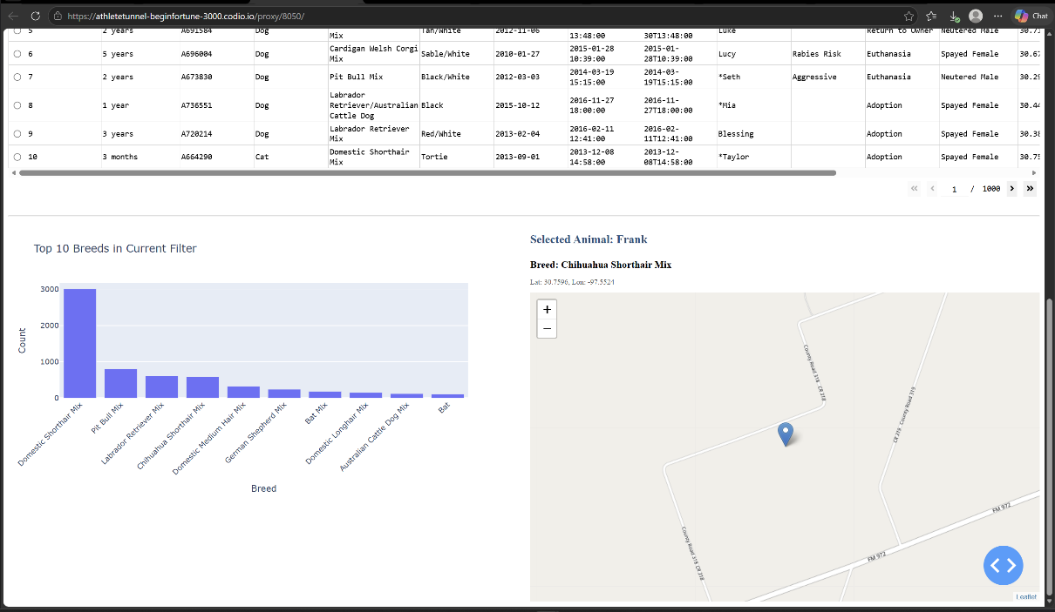
Dashboard visualization demonstrating dynamic graph and map updates after selecting and filtering rescue records from the MongoDB database.

Figure 3: Filtered Table Results
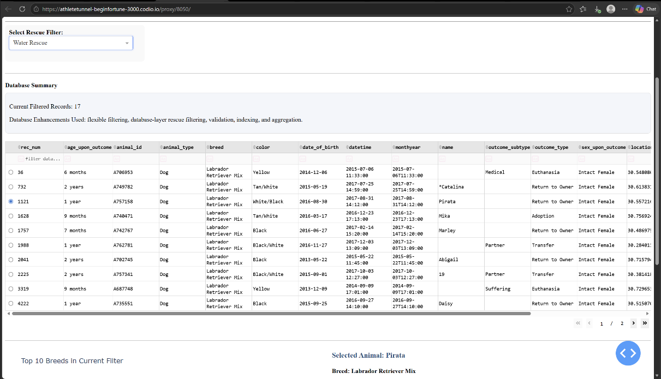
Interactive database table showing filtered MongoDB rescue records dynamically updating based on selected rescue categories.

Figure 4: Map Visualization Update
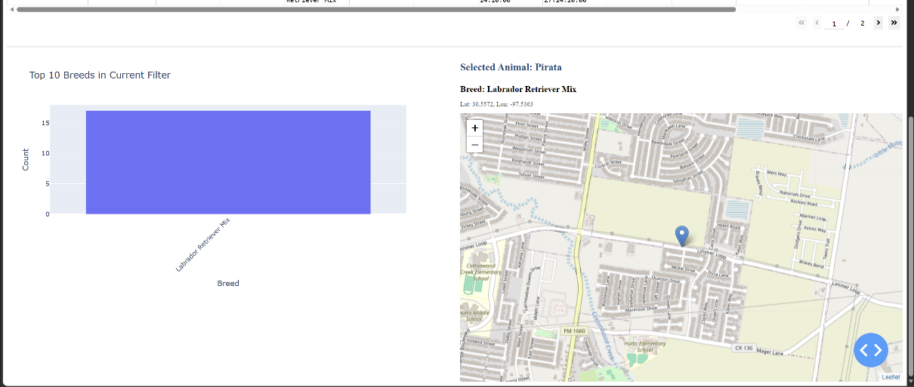
Interactive Dash Leaflet map demonstrating geographic location updates based on selected animal records within the dashboard table.

Figure 5: Graph and Map Filter Results
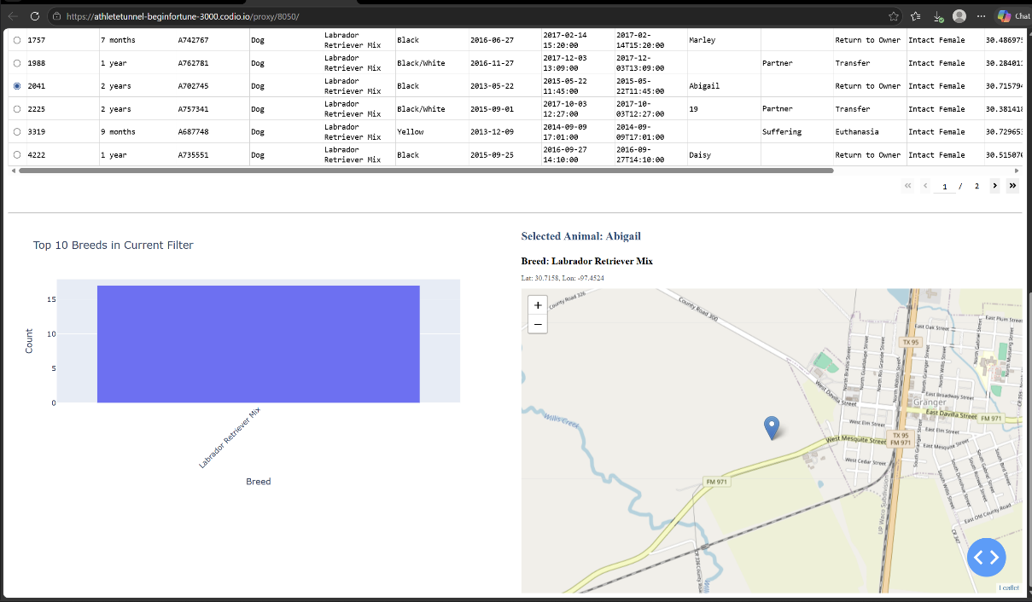
Updated dashboard graph and map output demonstrating integrated filtering functionality and synchronized visualization updates across dashboard components.

Figure 6: Full Dashboard Filter Example
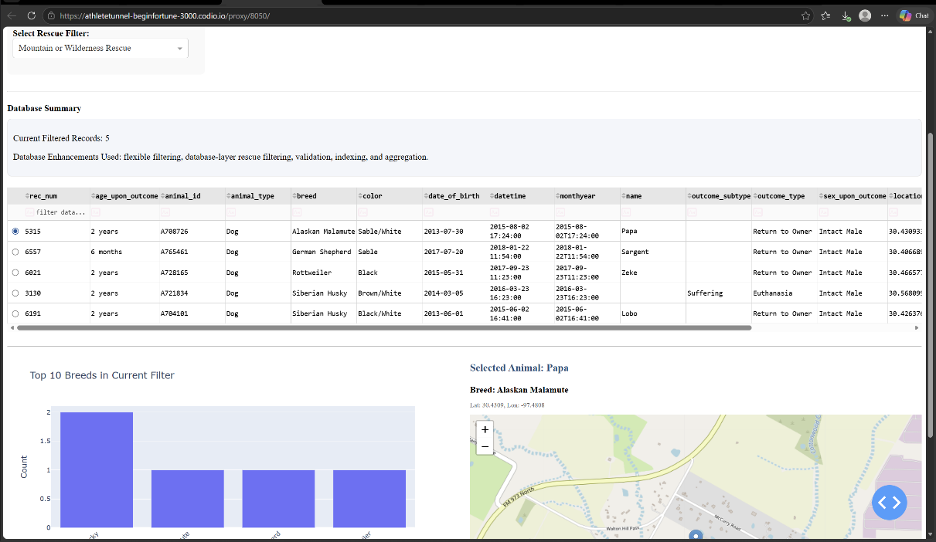
Complete dashboard interaction example demonstrating integrated functionality between the MongoDB database, filtering system, interactive table, graph visualization, and geographic mapping components.

Figure 7: Enhanced CRUD Python Module
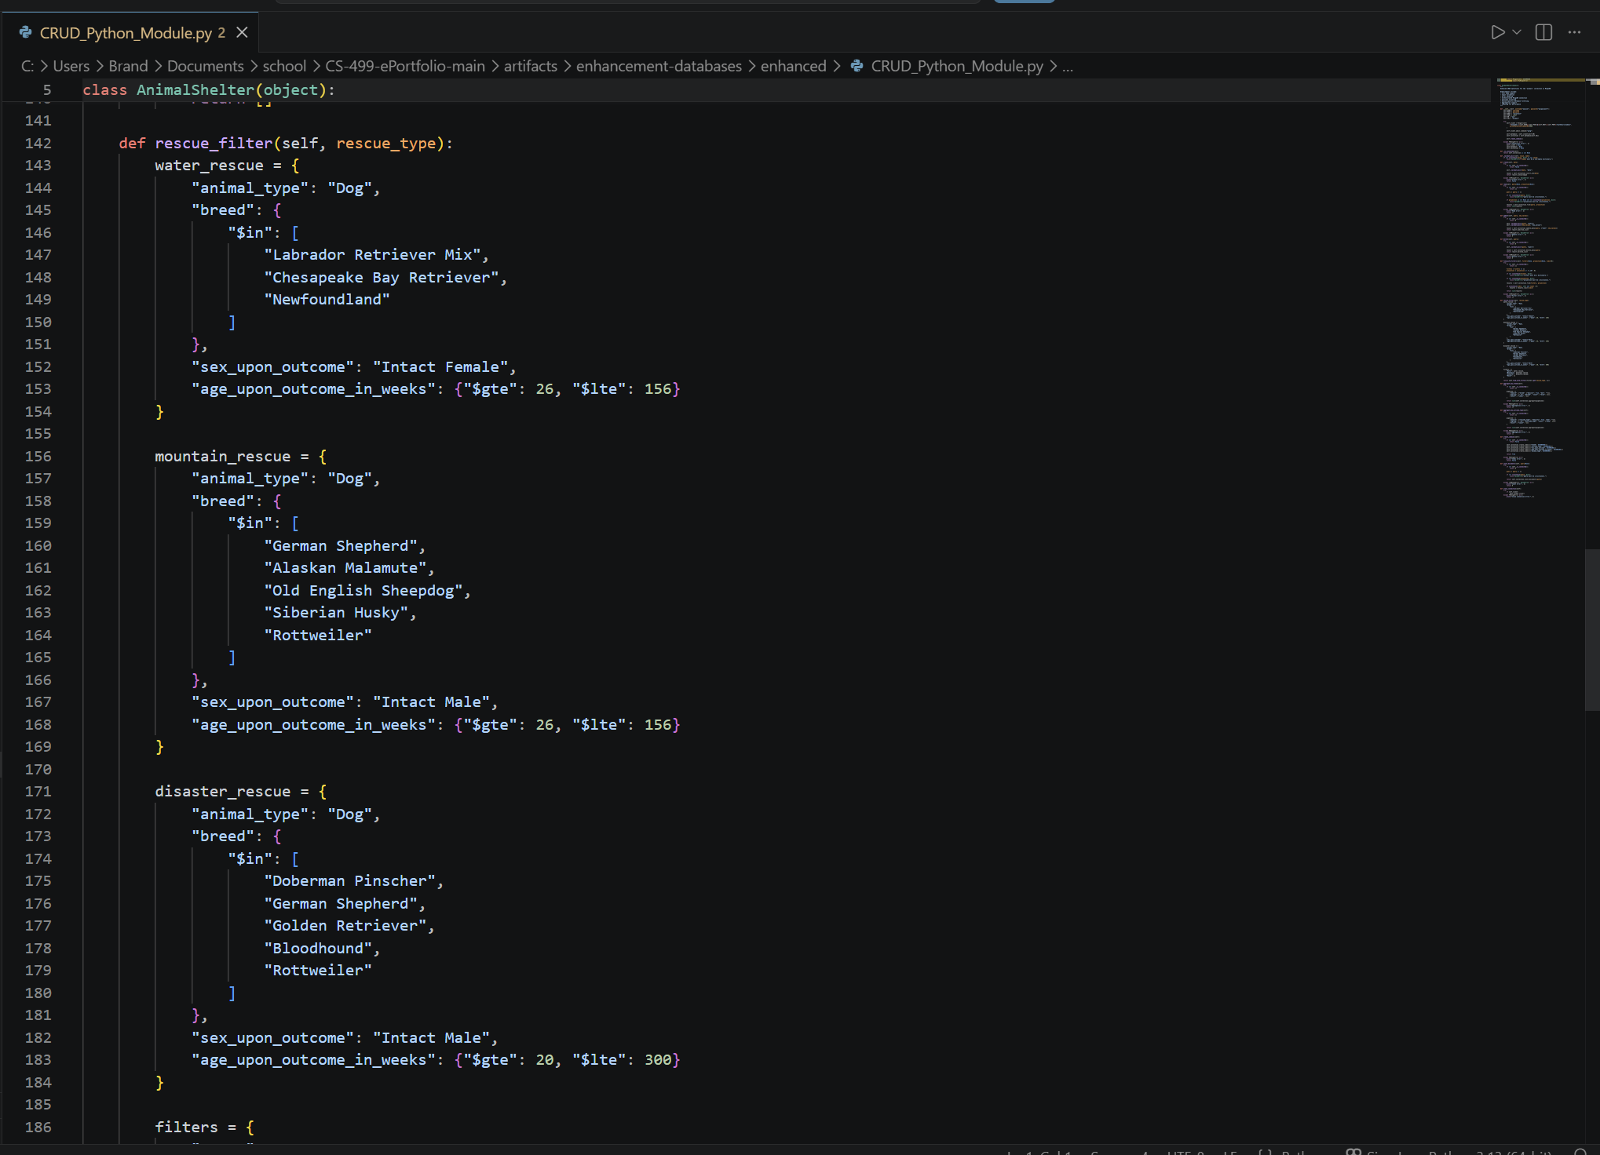
Enhanced CRUD Python module demonstrating reusable filtering methods, aggregation support, validation logic, indexing, and improved database-layer organization.

